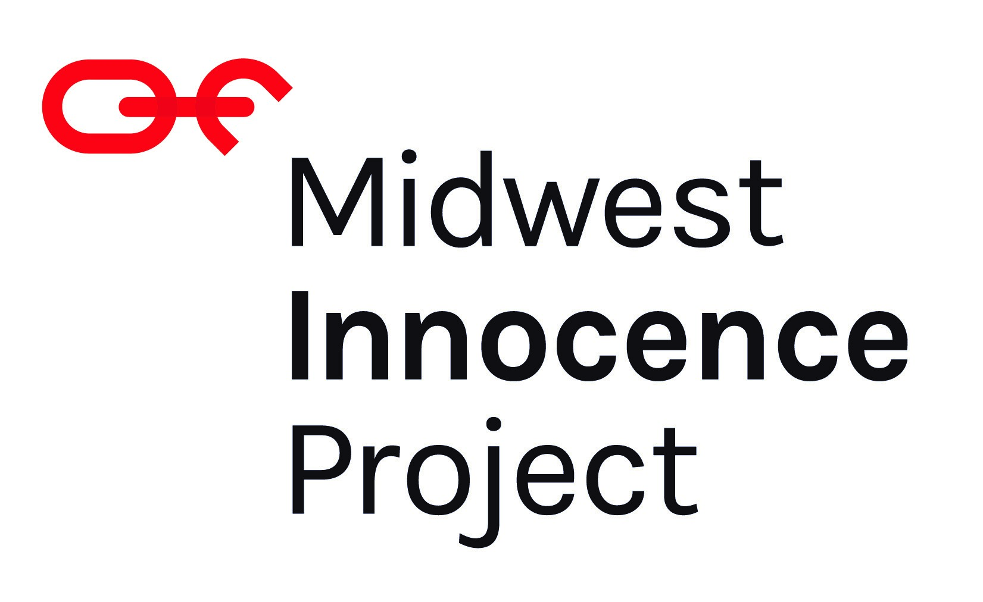

**Philanthropy Manager**

The Midwest Innocence Project (MIP) is a 501(c)(3) non-profit legal defense organization dedicated to freeing people convicted of crimes they did not commit in our five-state region (MO, KS, NE, IA, AR), supporting them upon release, and changing the system to prevent wrongful convictions in the first place. The Philanthropy Manager reports to MIP’s Deputy Director and is responsible for effectuating the following job responsibilities relevant to MIP’s development work.

The **Philanthropy Manager** is responsible for managing relationships with individuals and corporations in order to raise funds to support the mission of MIP.

**Job Description**

* Identify, cultivate, solicit, and steward individuals and corporations for major gifts ($5,000+) through all forms of contact, including in-person visits, and regular contact by e-mail and telephone.
* Manage a portfolio of 50-75 prospects, recording all substantive activities in the fundraising CRM.
* Working closely with the Deputy Director, develop comprehensive fundraising strategies to achieve visit, solicitation and financial goals.
* Monitor progress to goals and proactively adjust tactics and strategies when needed.
* Attend development team meetings.
* Represent MIP in community initiatives and events that support our mission and brand goals, and that engage key constituents.
* Foster and demonstrate a workplace inclusive of creating opportunity, serving others, building trust, innovation, and exceeding expectations.

**Qualifications:**

* A commitment to social justice and fundraising required;
* 1-2 years of fundraising or other transferrable experience;
* Strong written and verbal communication skills;
* Proficiency with the following systems strongly preferred: Neon CRM, Microsoft Office Suite, Dropbox.

Compensation is $55,000-$65,000 depending on experience. MIP offers a competitive salary and benefits package, including PTO and health insurance, and a positive, anti-racist, engaging, and flexible work environment.

**Application Instructions**

Please send a cover letter, resume, and a list of references to [jobs@themip.org](mailto:jobs@themip.org). Applications will be accepted until the position is filled.

.

The Midwest Innocence Project is an equal opportunity employer and strives for diversity among its applicant pool as well as within its staff and board. We strongly encourage people from all backgrounds, especially racial, ethnic, gender and sexual orientation minorities, veterans, people with disabilities, and smart people with non-linear/non-traditional experience and educational backgrounds to apply for this position. Most importantly, no matter their background, the person selected for this position must embrace, advocate for, and deeply value equity, diversity, and inclusivity.